Nepal’s extra bowler – Run-outs?

Whenever I have tuned in to watch a cricket match featuring Nepal, especially T20Is, I’ve witnessed Nepal tend to inflict a run-out or two every match. This got me thinking, does Nepal really inflict a lot of run-outs when fielding? And if they do, do these run-outs actually give them a benefit of an extra bowler. And so, I dove into the data -
Nepal played 17 T20 internationals in 2025, of which one was washed out. In this time, they beat the West Indies, and qualified for the T20 World Cup in 2026.
Here’s how the Rhinos have gotten their wickets in these 17 internationals –
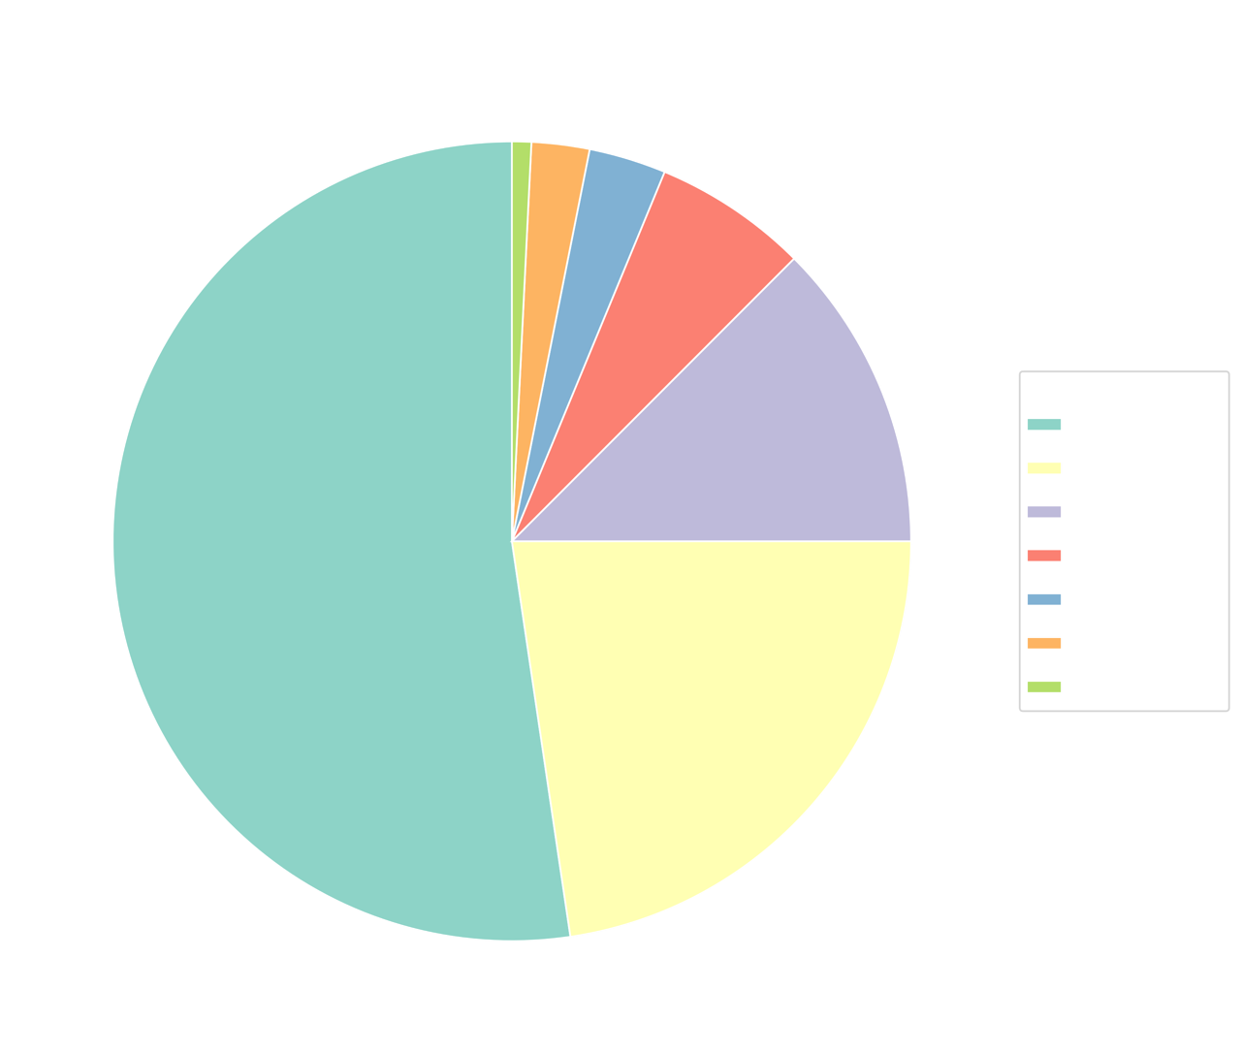
About 12.5% of the dismissals come from run-out and has been third on the list of Nepal’s mode of dismissal of opponent batsmen in 2025.
Of the 16 completed in 2025, there have been 11 matches where they’ve been able to inflict at least one run-out. Which means, 68.75% of the matches Nepal played this year, they’ve been involved with at least one run-out dismissal.
The maximum number of run-outs in a game has been the game against the UAE (1503460) in the World Cup Qualifiers. There were 3 run-outs that day, and Nepal went on to win the game by one run.
One of the reasons behind the run-outs dismissal has to be Nepal’s ability to get direct hits. In 2025 -
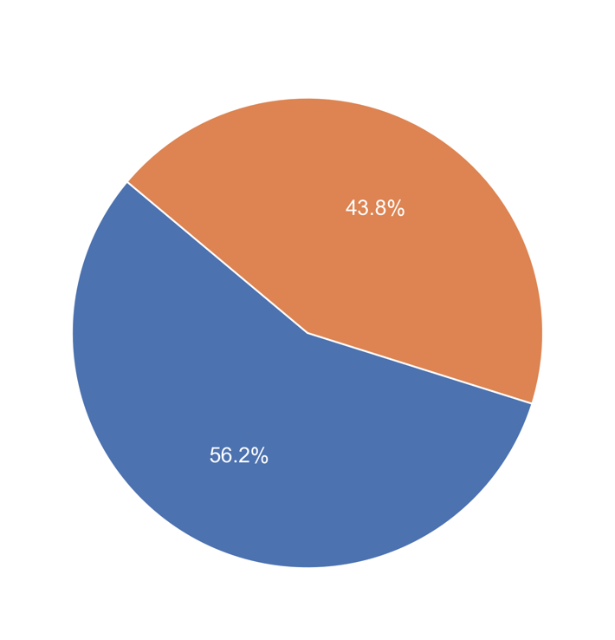
56% of run-outs were direct hits. And the other 44% were with wicket-keepers involved. Direct hits are often close calls—and Nepal have been hitting the wickets quite frequently.
Dipendra Singh Airee, Nepal’s gun fielder, has been heads above anybody else in the team. He alone has 6 run-outs this year, 5 of which are direct hits. The rest of the team has also contributed to the run-out counts, but none more so than DS Airee.

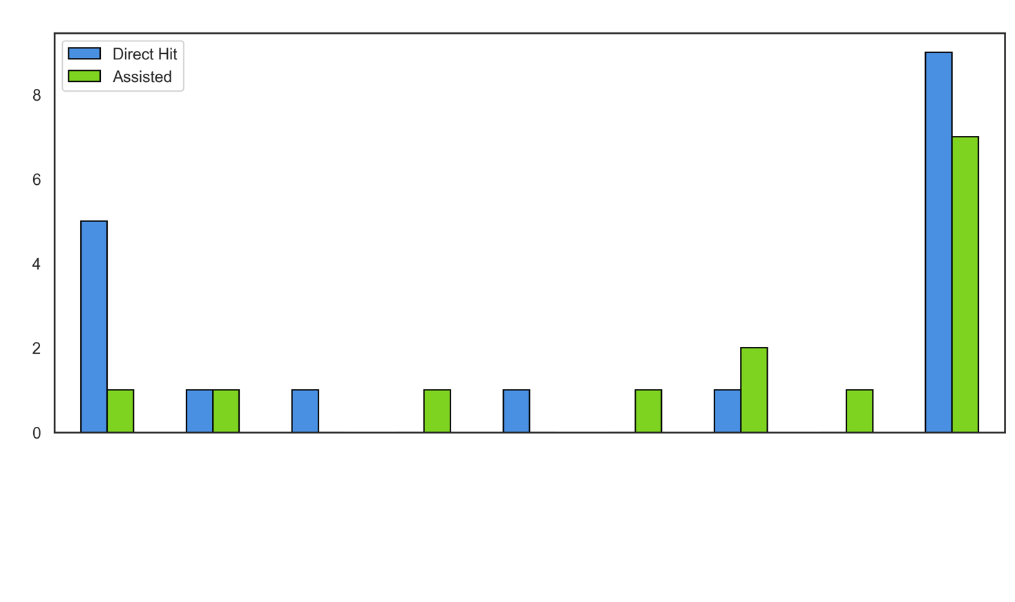

Most run-outs victims have been the middle order batsmen (4-8), and it goes to show, Nepali fielders become that extra bowler in the middle over, taking crucial wickets. There are also a few run-out victims at the top of the order, and only one victim is a lower-order batsman.
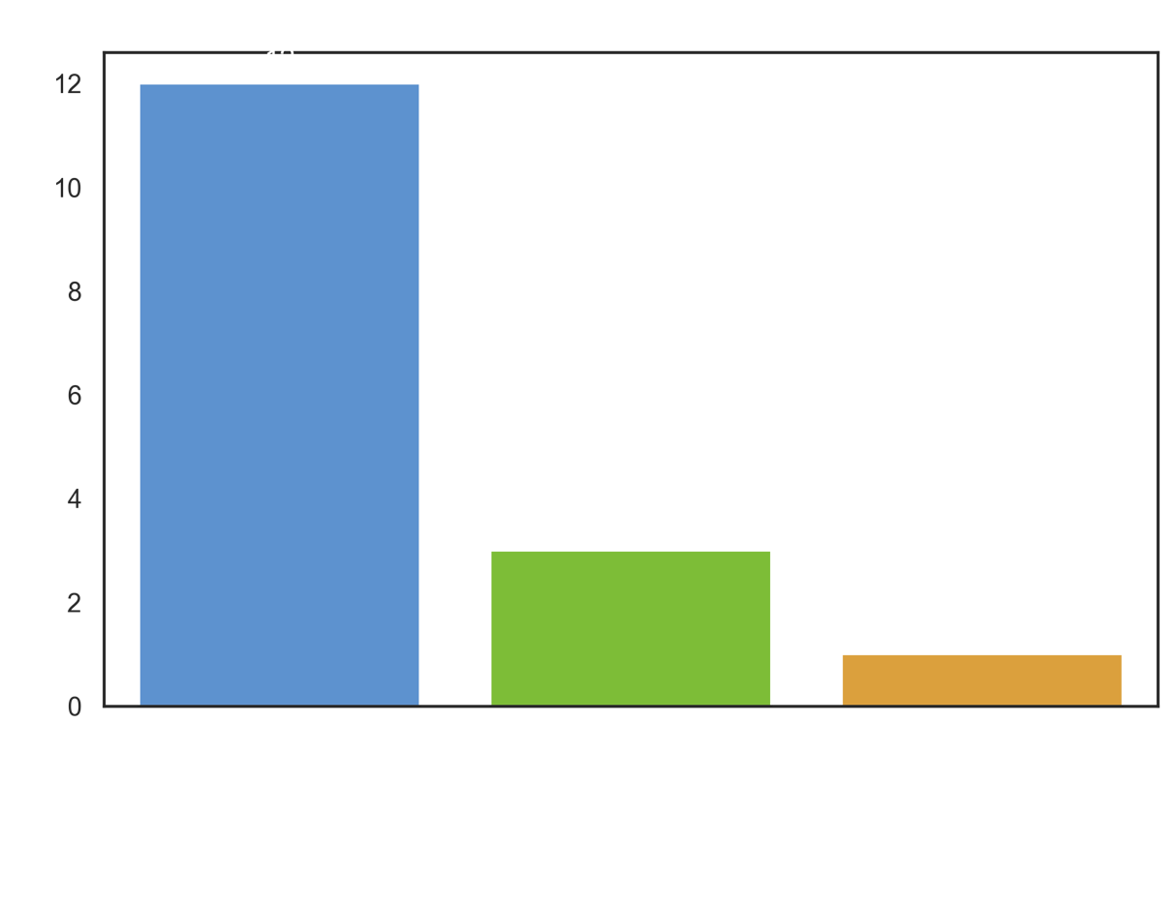

Staggeringly, Nepal have won 10 out of the 11 games, where they’ve inflicted run-outs. It’s like the adage “Catches win matches” in Nepal’s case has turned to “Catches win matches, but run outs are the icing on the cake.”
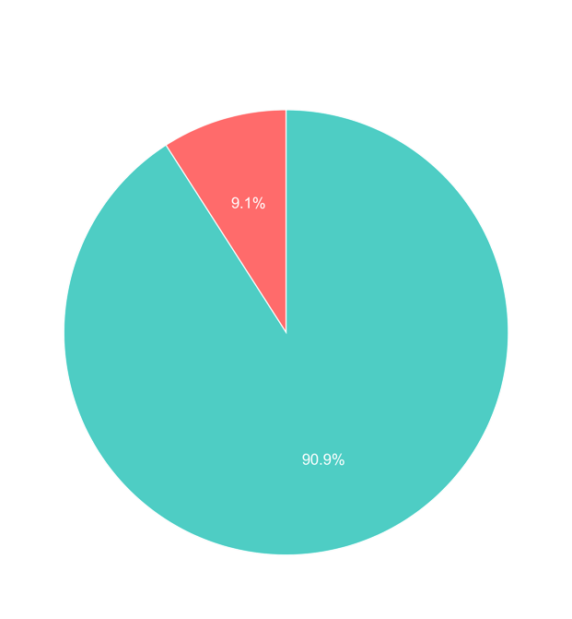
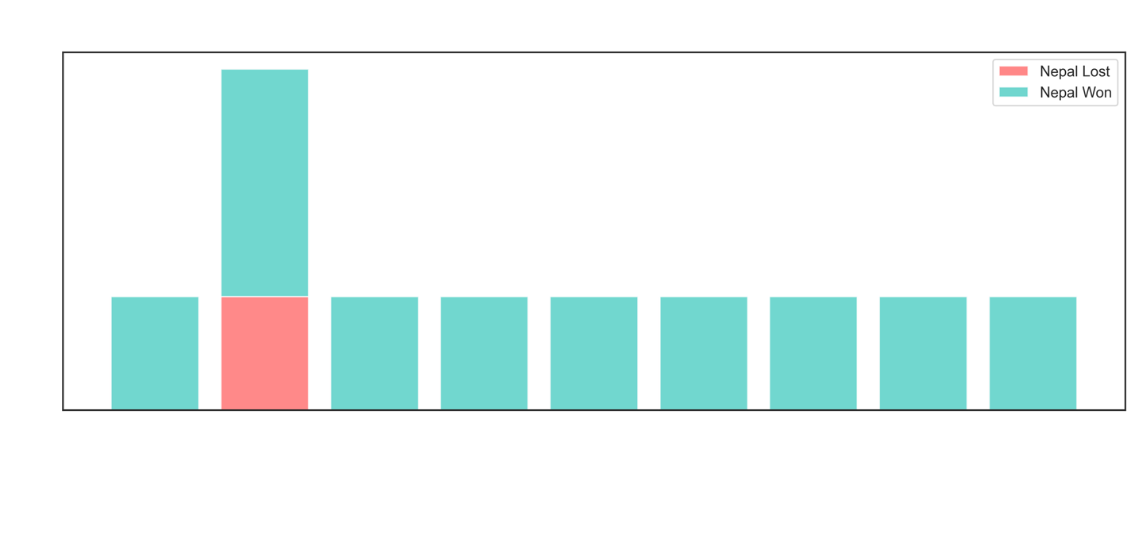

Nepal has consistently shown they’ve been a good fielding side, but now, with these numbers to back it up, it’s only a sign of good things to come for this talented Nepali side.

How often are Nepali batters dismissed via run-out?

At first glance, it seems as if Nepali batsmen have a habit of getting themselves run out. And an ardent Rhinos supporter would go so far as to say – Nepali batsmen run themselves out far too often.
However, when examining the data for T20I matches played in 2025, the Nepali team tends to get opposition batsmen run out far more often than their own batsmen are run out.
They’ve found their batters being run out in 7 matches, and a total of 9 times, from the 16 completed matches in 2025. They’ve lost two wickets to run out twice, once with Scotland and the other in the third T20I against the West Indies - they’ve gone one to lose both the matches.
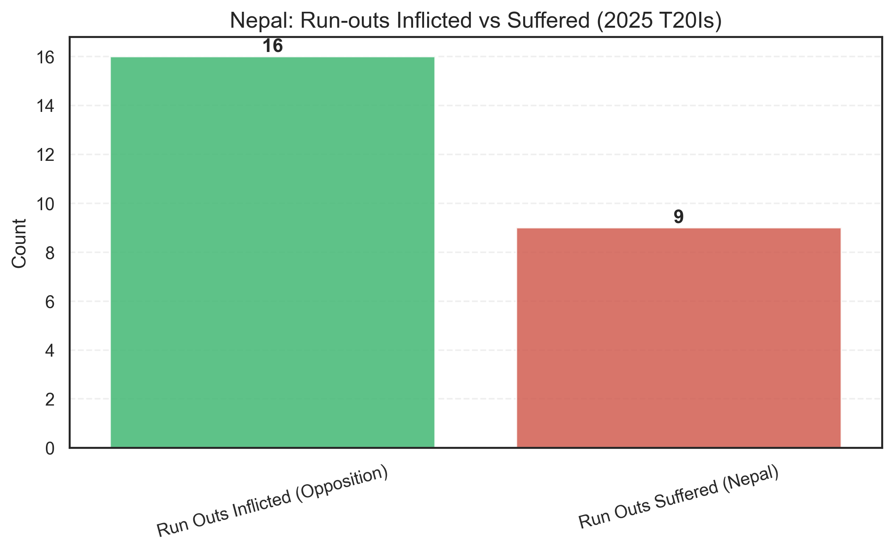
Win-loss ratio when run outs have occurred :
Out of the 7 matches, Nepal have lost 3 and won 4, and the two losses have come when they’ve lost more than one wicket to run out.
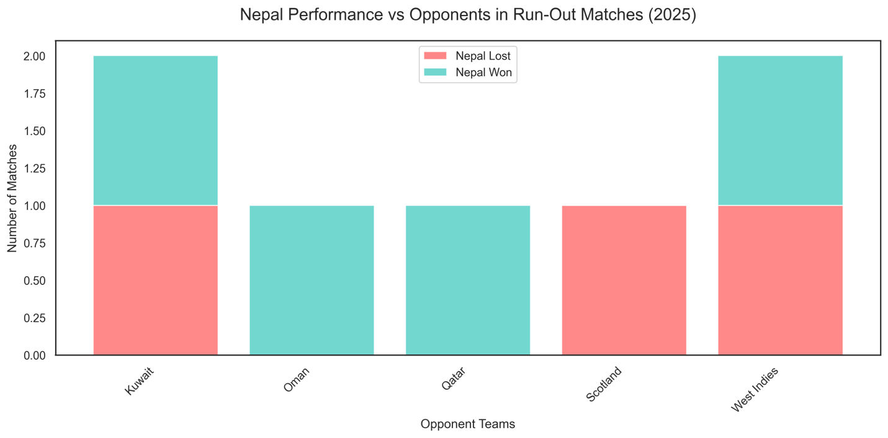

How much better was Nepal at inflicting run-outs compared to being dismissed by run-out in 2025?
Percentage Difference=(16−9) /9= 0.78
Nepal produce ~78% more run-outs dismissal than they incur.

Order of batsmen run out
It was mostly the batsmen in the lower order (9 to 11) and Lower middle order (7 and 8) that were run out 5 times in total. Given that these batsmen are often looking for quick runs and historically, knowing how to run between the wickets from lower-order batsmen, this is expected behavior. Only once in the 16 innings, was a top order batsman run out and 3 times was the middle order batsmen run out.
